MainActivity.xml

<?xml version="1.0" encoding="utf-8"?>
<androidx.constraintlayout.widget.ConstraintLayout xmlns:android="http://schemas.android.com/apk/res/android"
xmlns:app="http://schemas.android.com/apk/res-auto"
xmlns:tools="http://schemas.android.com/tools"
android:id="@+id/main"
android:layout_width="match_parent"
android:layout_height="wrap_content"
tools:context=".views.activities.MainActivity">
<com.google.android.material.appbar.MaterialToolbar
android:id="@+id/Toolbar"
android:layout_width="match_parent"
android:layout_height="wrap_content"
android:background="#09B3FF"
android:minHeight="?attr/actionBarSize"
android:theme="?attr/actionBarTheme"
app:layout_constraintEnd_toEndOf="parent"
app:layout_constraintStart_toStartOf="parent"
app:layout_constraintTop_toTopOf="parent"
app:titleTextColor="@color/black"/>
<LinearLayout
android:id="@+id/linearLayout2"
android:layout_width="match_parent"
android:layout_height="wrap_content"
android:background="#09B3FF"
android:orientation="horizontal"
android:padding="15dp"
app:layout_constraintEnd_toEndOf="parent"
app:layout_constraintStart_toStartOf="parent"
app:layout_constraintTop_toBottomOf="@+id/Toolbar">
<ImageView
android:id="@+id/perviousDateBtn"
android:layout_width="19dp"
android:layout_height="23dp"
app:srcCompat="@drawable/previous"
tools:ignore="ContentDescription" />
<TextView
android:id="@+id/currentDate"
android:layout_width="0dp"
android:layout_height="wrap_content"
android:layout_weight="1"
android:gravity="center"
android:text="Sep 2, 2024"
android:textColor="@color/black"
android:textColorLink="#09B1FD"
android:textSize="16sp"
tools:ignore="HardcodedText" />
<ImageView
android:id="@+id/nextDateBtn"
android:layout_width="19dp"
android:layout_height="22dp"
app:srcCompat="@drawable/next"
tools:ignore="ContentDescription" />
</LinearLayout>
<com.google.android.material.tabs.TabLayout
android:id="@+id/tabLayout"
android:layout_width="match_parent"
android:layout_height="wrap_content"
android:background="#09B2FE"
app:layout_constraintEnd_toEndOf="parent"
app:layout_constraintStart_toStartOf="parent"
app:layout_constraintTop_toBottomOf="@+id/linearLayout2"
app:tabIndicatorColor="#00838F"
app:tabMode="fixed"
app:tabTextColor="@color/white">
<com.google.android.material.tabs.TabItem
android:layout_width="wrap_content"
android:layout_height="wrap_content"
android:text="Daily"
tools:ignore="HardcodedText" />
<com.google.android.material.tabs.TabItem
android:layout_width="wrap_content"
android:layout_height="wrap_content"
android:text="Monthly"
tools:ignore="HardcodedText" />
<com.google.android.material.tabs.TabItem
android:layout_width="wrap_content"
android:layout_height="wrap_content"
android:text="Calendar"
tools:ignore="HardcodedText" />
<com.google.android.material.tabs.TabItem
android:layout_width="wrap_content"
android:layout_height="wrap_content"
android:text="Summary"
tools:ignore="HardcodedText" />
<com.google.android.material.tabs.TabItem
android:layout_width="wrap_content"
android:layout_height="wrap_content"
android:text="Notes"
tools:ignore="HardcodedText" />
</com.google.android.material.tabs.TabLayout>
<LinearLayout
android:id="@+id/linearLayout7"
android:layout_width="match_parent"
android:layout_height="wrap_content"
android:orientation="horizontal"
android:padding="5dp"
app:layout_constraintTop_toBottomOf="@+id/tabLayout"
tools:ignore="DisableBaselineAlignment">
<LinearLayout
android:layout_width="match_parent"
android:layout_height="match_parent"
android:layout_weight="1"
android:gravity="center"
android:orientation="vertical">
<TextView
android:id="@+id/textView8"
android:layout_width="match_parent"
android:layout_height="wrap_content"
android:gravity="center"
android:text="Income"
tools:ignore="HardcodedText" />
<TextView
android:id="@+id/incomeLbl"
android:layout_width="match_parent"
android:layout_height="wrap_content"
android:layout_marginTop="3dp"
android:gravity="center"
android:text="0.0"
android:textColor="#00FF00"
tools:ignore="HardcodedText" />
</LinearLayout>
<LinearLayout
android:layout_width="match_parent"
android:layout_height="match_parent"
android:layout_weight="1"
android:gravity="center"
android:orientation="vertical">
<TextView
android:id="@+id/textView6"
android:layout_width="match_parent"
android:layout_height="wrap_content"
android:gravity="center"
android:text="Expense"
tools:ignore="HardcodedText" />
<TextView
android:id="@+id/expenseLbl"
android:layout_width="match_parent"
android:layout_height="wrap_content"
android:layout_marginTop="3dp"
android:gravity="center"
android:text="0.0"
android:textColor="#FF0000"
tools:ignore="HardcodedText" />
</LinearLayout>
<LinearLayout
android:layout_width="match_parent"
android:layout_height="match_parent"
android:layout_weight="1"
android:gravity="center"
android:orientation="vertical">
<TextView
android:id="@+id/textView3"
android:layout_width="match_parent"
android:layout_height="wrap_content"
android:gravity="center"
android:text="Total"
tools:ignore="HardcodedText" />
<TextView
android:id="@+id/totalLbl"
android:layout_width="match_parent"
android:layout_height="wrap_content"
android:layout_marginTop="3dp"
android:gravity="center"
android:text="0.0"
tools:ignore="HardcodedText" />
</LinearLayout>
</LinearLayout>
<com.google.android.material.bottomnavigation.BottomNavigationView
android:id="@+id/bottomNavigationView"
android:layout_width="match_parent"
android:layout_height="wrap_content"
android:layout_marginTop="540dp"
android:layout_weight="1"
android:background="#09B2FE"
app:itemIconTint="@color/black"
app:itemTextColor="@color/white"
app:labelVisibilityMode="labeled"
app:layout_constraintBottom_toBottomOf="parent"
app:layout_constraintEnd_toEndOf="parent"
app:layout_constraintHorizontal_bias="0.0"
app:layout_constraintStart_toStartOf="parent"
app:layout_constraintTop_toBottomOf="@+id/linearLayout7"
app:menu="@menu/bottom_menu" />
<com.google.android.material.floatingactionbutton.FloatingActionButton
android:id="@+id/FloatingActionButton"
android:layout_width="wrap_content"
android:layout_height="wrap_content"
android:layout_marginEnd="8dp"
android:layout_marginBottom="8dp"
android:clickable="true"
app:backgroundTint="#09B1FD"
app:layout_constraintBottom_toTopOf="@+id/bottomNavigationView"
app:layout_constraintEnd_toEndOf="parent"
app:srcCompat="@drawable/plus"
tools:ignore="ContentDescription,KeyboardInaccessibleWidget" />
<androidx.recyclerview.widget.RecyclerView
android:id="@+id/transactionsList"
android:layout_width="0dp"
android:layout_height="0dp"
app:layout_constraintBottom_toTopOf="@+id/bottomNavigationView"
app:layout_constraintEnd_toEndOf="parent"
app:layout_constraintHorizontal_bias="0.0"
app:layout_constraintStart_toStartOf="parent"
app:layout_constraintTop_toBottomOf="@+id/linearLayout7"
tools:listitem="@layout/row_transaction"/>
<ImageView
android:id="@+id/nodata"
android:layout_width="100dp"
android:layout_height="100dp"
android:alpha="0.5"
android:visibility="gone"
app:layout_constraintBottom_toTopOf="@+id/bottomNavigationView"
app:layout_constraintEnd_toEndOf="@+id/transactionsList"
app:layout_constraintStart_toStartOf="parent"
app:layout_constraintTop_toBottomOf="@+id/linearLayout7"
app:srcCompat="@drawable/no_data"
tools:ignore="ContentDescription" />
</androidx.constraintlayout.widget.ConstraintLayout>

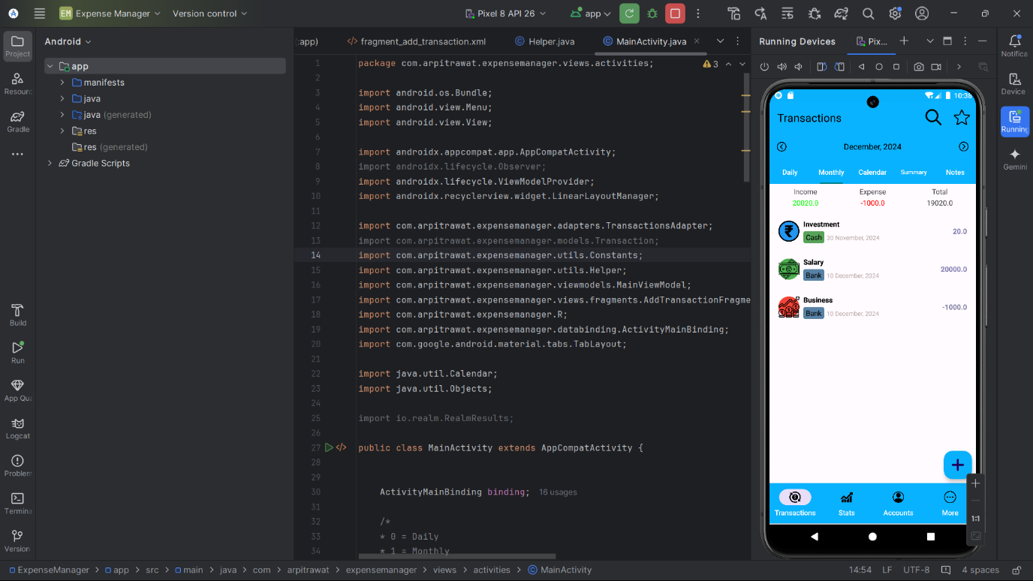

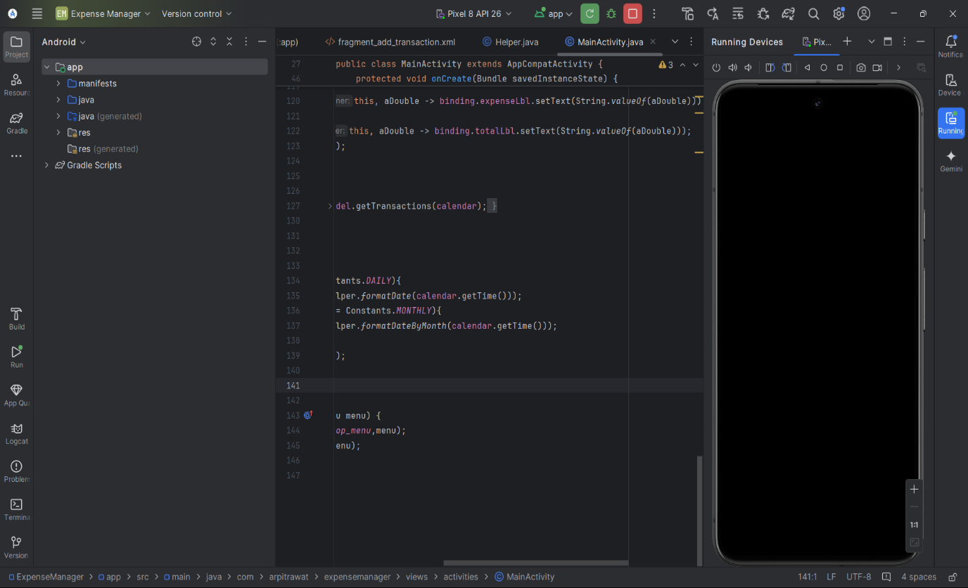

MainActivity.java

package com.arpitrawat.expensemanager.views.activities;
import android.os.Bundle;
import android.view.Menu;
import android.view.View;
import androidx.appcompat.app.AppCompatActivity;
import androidx.lifecycle.Observer;
import androidx.lifecycle.ViewModelProvider;
import androidx.recyclerview.widget.LinearLayoutManager;
import com.arpitrawat.expensemanager.adapters.TransactionsAdapter;
import com.arpitrawat.expensemanager.models.Transaction;
import com.arpitrawat.expensemanager.utils.Constants;
import com.arpitrawat.expensemanager.utils.Helper;
import com.arpitrawat.expensemanager.viewmodels.MainViewModel;
import com.arpitrawat.expensemanager.views.fragments.AddTransactionFragment;
import com.arpitrawat.expensemanager.R;
import com.arpitrawat.expensemanager.databinding.ActivityMainBinding;
import com.google.android.material.tabs.TabLayout;
import java.util.Calendar;
import java.util.Objects;
import io.realm.RealmResults;
public class MainActivity extends AppCompatActivity {
ActivityMainBinding binding;
/*
* 0 = Daily
* 1 = Monthly
* 2 = Calendar
* 3 = Summary
* 4 = Notes
*/
Calendar calendar;
public MainViewModel viewModel;
@Override
protected void onCreate(Bundle savedInstanceState) {
super.onCreate(savedInstanceState);
binding = ActivityMainBinding.inflate(getLayoutInflater());
setContentView(binding.getRoot());
viewModel = new ViewModelProvider(this).get(MainViewModel.class);
setSupportActionBar(binding.Toolbar);
Objects.requireNonNull(getSupportActionBar()).setTitle("Transactions");
Constants.setCategories();
calendar = Calendar.getInstance();
updateDate();
binding.nextDateBtn.setOnClickListener(c->{
if (Constants.SELECTED_TAB == Constants.DAILY) {
calendar.add(Calendar.DATE, 1);
}else if (Constants.SELECTED_TAB == Constants.MONTHLY){
calendar.add(Calendar.MONTH, 1);
}
updateDate();
});
binding.perviousDateBtn.setOnClickListener(c->{
if (Constants.SELECTED_TAB == Constants.DAILY) {
calendar.add(Calendar.DATE, -1);
}else if (Constants.SELECTED_TAB == Constants.MONTHLY){
calendar.add(Calendar.MONTH, -1);
}
updateDate();
});
binding.FloatingActionButton.setOnClickListener(c-> new AddTransactionFragment().show(getSupportFragmentManager(), null));
binding.transactionsList.setLayoutManager(new LinearLayoutManager(this));
viewModel.transactions.observe(this, transactions -> {
TransactionsAdapter transactionsAdapter = new TransactionsAdapter(MainActivity.this, transactions);
binding.transactionsList.setAdapter(transactionsAdapter);
if(!transactions.isEmpty()) {
binding.nodata.setVisibility(View.GONE);
}else {
binding.nodata.setVisibility(View.VISIBLE);
}
});
binding.tabLayout.addOnTabSelectedListener(new TabLayout.OnTabSelectedListener() {
@Override
public void onTabSelected(TabLayout.Tab tab) {
if (Objects.equals(tab.getText(), "Monthly")){
Constants.SELECTED_TAB = 1;
updateDate();
}else if (Objects.equals(tab.getText(), "Daily")){
Constants.SELECTED_TAB = 0;
updateDate();
}
}
@Override
public void onTabUnselected(TabLayout.Tab tab) {
}
@Override
public void onTabReselected(TabLayout.Tab tab) {
}
});
viewModel.totalIncome.observe(this, aDouble -> binding.incomeLbl.setText(String.valueOf(aDouble)));
viewModel.totalExpense.observe(this, aDouble -> binding.expenseLbl.setText(String.valueOf(aDouble)));
viewModel.totalAmount.observe(this, aDouble -> binding.totalLbl.setText(String.valueOf(aDouble)));
viewModel.getTransactions(calendar);
}
public void getTransactions(){
viewModel.getTransactions(calendar);
}
void updateDate(){
if (Constants.SELECTED_TAB == Constants.DAILY){
binding.currentDate.setText(Helper.formatDate(calendar.getTime()));
}else if (Constants.SELECTED_TAB == Constants.MONTHLY){
binding.currentDate.setText(Helper.formatDateByMonth(calendar.getTime()));
}
viewModel.getTransactions(calendar);
}
@Override
public boolean onCreateOptionsMenu(Menu menu) {
getMenuInflater().inflate(R.menu.top_menu,menu);
return super.onCreateOptionsMenu(menu);
}
}

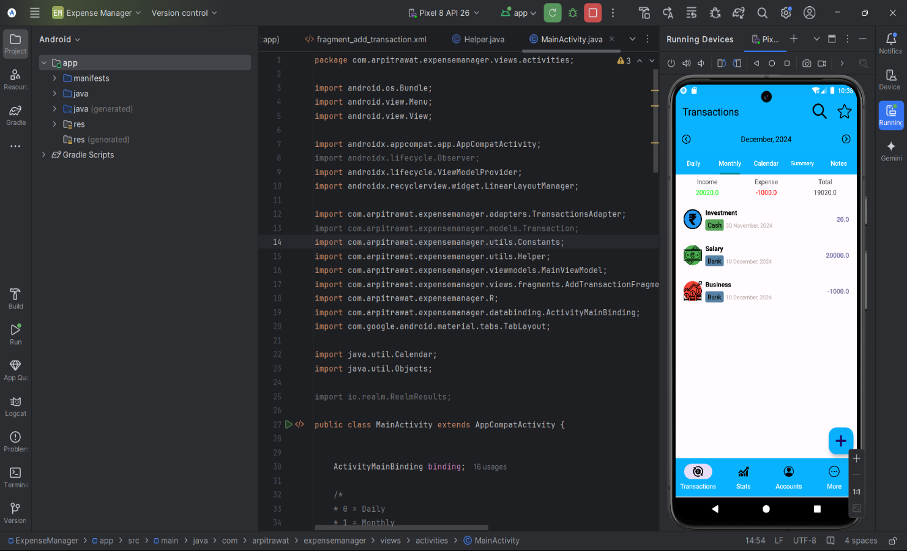

OUTPUT:-

